Contents

**A.** **INTRODUCTION** 1

**I.** **Task Management System Introduction** 1

**II.** **Initial Ideal of the Group** 2

**III.** **Existing Products& Systems** 2

**1.** **2Do: To Do List | Task List** 3

**2.** **GTasks: To Do List & Task List** 3

**3.** **Air To-Do** 4

**4.** **Limitations of the existing products and systems** 5

**5.** **Advantages of our new system** 5

**IV.** **Our solution and Purposes** 6

**1.** **Solution and Improvement** 6

**2.** **Our purposes** 6

**B.** **PROJECT MANAGEMENT PLAN** 6

**C.** **SOFTWARE REQUIREMENT SPECIFICATION** 6

**D.** **DESIGN & IMPLEMENTATION** 6

**E.** **TEST DOCUMENTATION** 6

**F.** **USER’S MANUAL** 6

**G.** **APPENDIX** 7

1. **INTRODUCTION**
2. **Task Management System Introduction**

People must often face up to pressure of work, family and social work in modern life. There is a long list of individual work, family work, agency work as well as social activities. All those tasks need to be remembered and carried out on time as well as exactly. Many people knew how to remember and organize their tasks. Generally, the simplest way is using the notebook to take notes and plan their tasks. If you ask anybody who was born in the late 70s about how to organize their work, you will see some small notebooks, or simply some piece of papers which recorded the daily tasks was stuck at the visible places such as the fridge, dressing table, wall calendar or desk. Moreover, for people who were born in the 80s, they used to use Sticky Notes (the software that is built into Windows) or the software notes, tasks management, schedule management and so on… to manage their tasks. Especially, most of the first generations of cell phones like Nokia, Motorola and Black Berry have owned the remindful software, creating simple schedule which was installed in their phone available.

Nowadays, Smartphone has gradually replaced traditional mobile phones; therefore, a series of applications for task management and schedule programming have been dramatically developed with a lot of powerful functions to assit the task management and work organization by programmers. By using a few simple steps, users can build the list of tasks with the functions of notification, alarm, sorting and checklist. Nevertheless, most applications only support personal task management, not having those functions in group project tasks’ management. Besides, it has not been yet the functions of sharing job or communication among people within using the same system.

These are the reasons why people need an integrated system that allow users can manage tasks, task sharing and communication channels to support their works.

1. **Initial Ideal of the Group**

The project’s main objective is to build systems consist to build and manage tasks, combine share tasks and communication systems pass by message among users. Our purpose is applying an application in project management.

Our application that allows users can manage themselves tasks and tasks of projects or teams. Moreover, our application helps users can communicate to other user in the application system by sending messages and sharing task functions

After reading a research report about Smartphone in Vietnam, we realize that smart phones use Android system , a system that is being interested in, and occupy the most of market field, we decided to write a android system

~~After talking with Mr. VinhCX –~~ we discussed about software development tendency, and we known about SOA (Service Oriented Architecture), Cloud Computing and Mobile Application are favorite topics that was discussed a lot in many technical forums.

And at last, we decided to build a system that include:

* Android device is client system that is used for user to interact with the application. It can be also developed on other mobile platform such as iOS…
* Web services are developed by WCF…. Business Logic, backend, platform-independent
* Database will be deployed on Cloud Computing. High scalability, high performance…

1. **Existing Products& Systems**

Currently there are several similar products

1. **2Do: To Do List | Task List**

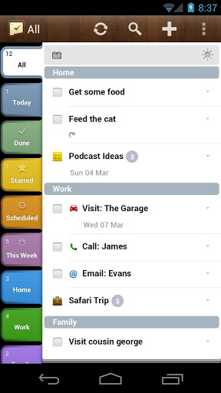

**2Do: To Do List** is a software product from **Guided Ways Technologies Ltd**. 2Do: To Do List is introduced to be able to run on 3 environments (Android, iOs, Mac OS) and support Smartphone, tablets, and Mac computer. 2Do is incredibly powerful software. This feature-packed productivity app provides everything you need to manage your daily tasks. 2Do includes a helpful tutorial on how to get started. Creating a new to-do list is pretty easy, and the app includes a variety of options for each task. For each item on your 2Do list, you can also add notes, set a due date, tag a location, schedule an alarm, and tack on a URL or photo. You can even make an audio recording with voice notes.

1. **GTasks: To Do List & Task List**

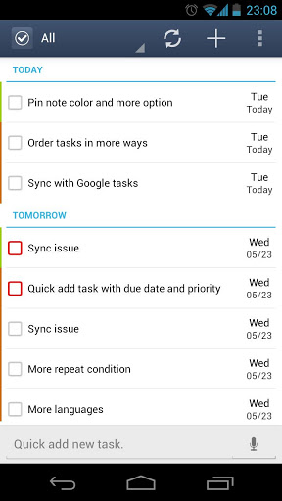

**GTasks** is a software product from **Appest Inc.** Gtask is run only on Android. It supports smart phone and tablets. Gtasks is my favorite To-do list app, because it’s simple and efficient task management. In-app, you can set ring tone reminders, create individual tasks, or categories of lists. You can change the name, color, order of your lists and sync with your Google tasks perfectly. With the simple swipe of a finger, you can scroll between the categories, and quickly pull up what you’re supposed to be doing next. The widgets are good-looking, and flexible

1. **Air To-Do**

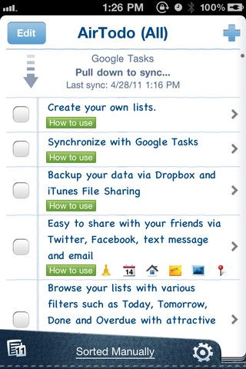

**Air To-Do**is a software product from  AllAboutApps Inc. Air To-Do is run on iOS 3.1 or later. It is compatible with iPhone, iPod touch, and iPad. Air To-Do’s interface is very simple, which is a plus for a list app. For each individual item, you can add a due date, set an alert, add a URL or photo, write a note, or tag a location. Air To-Do also includes plenty of sharing options, including the ability to send items via email or text message. One thing I really like about the Air To-Do app is its integration with Facebook and Twitter.

1. **Limitations of the existing products and systems**

|  |  |  |  |
| --- | --- | --- | --- |
| **No** | **Product Name** | **Limitations** | |
| **Features** | **User Interface** |
| 1 | 2Do: To Do List | Task List | Not support drag and drop tasks | Slightly confusing at first |
| 2 | GTasks: To Do List & Task List | -Cannot create Multi task  -Haven't task categories | Not show due time |
| 3 | Air To-Do | -No option to sort or reorder list  -Only one list | Display too simple and too little information |

Trinh bay lai theo cau truc Matrix

1. **Advantages of our new system**

-Developing base on cloud computing

- Can share task to other people

- Members can communicate via messaging system

- Support drag and drop tasks.

1. **Our solution and Purposes**
2. **Solution and Improvement**

Mobile Project Management is a software system that follows Three-Tier architecture model. The components in Three-Tier architecture model are:

* Presentation Tier is a Fat Client is developed to run on mobile devices using the Android operating system (iOS, Windows Phone). This application has the function to display information related to the services to be deployed on the server side. Users can perform actions such as adding a new task, task management, Organization development, task sharing, and communicate with other users in the system.
* Business Logic Tier includes Web Services Developed by WCF service based ​​C Sharp programming languages. These services will work directly with Data Tier.
* Data Tier is where to store the database and system files

Chuyen 3 Tier xuong phan Design

The development of information technology appears to assist almost all people to have a smart phone; they can check the daily work anytime and anywhere, to avoid the miss or lack of tasks. The Mobile Project Management will support users to manage our work more efficiently. People can easily manage their work through mobile phones. Users can manage their tasks and tasks of projects or teams. Moreover, our application helps users can communicate to other user in the application system by sending messages and sharing task functions

Can noi ve Mobile, va Cloud o day. Cac Tier chi la muc con trong Mobile hoac Cloud

Mobile

* List of advantage
* …
* Android market

Cloud

* High scalability
* High performance
* Cost saving…

1. **Our purposes**

This project is registered and implemented as the capstone project for the team members. The first purpose is to fulfill the requirements from FPT University studying program. The second purpose is to create a complete product for going lives

Help enterprise company to manage project

Help persons to manage their personal tasks…

Commercial app

1. **PROJECT MANAGEMENT PLAN**
2. **SOFTWARE REQUIREMENT SPECIFICATION**
3. **DESIGN & IMPLEMENTATION**
4. **TEST DOCUMENTATION**
5. **USER’S MANUAL**
6. **APPENDIX**